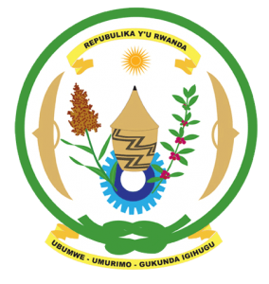
27th Session of the Universal Periodic Review Working Group
Review of South Africa
10th May 2017
Statement by Rwanda delivered by Mr. Moses Rugema
Thank you Mr. President,
- Rwanda warmly welcomes the delegation of South Africa and thanks them for the presentation of their national report and the update just provided.
- We welcome the positive steps taken by South Africa since its last UPR including ratification of the ICESCR and the implementation of various legislative and policy measures to improve the economic and social well-being of its citizens.
- While noting the efforts to combat sexual and gender-based violence, we encourage South Africa to enhance those efforts including through the implementation of relevant laws to ensure justice for victims.

Rwanda recommends that South Africa:
- Strengthen measures to prevent and eradicate all manifestations of discrimination, xenophobia and violence against foreign nationals.
- Intensifies its efforts to ratify the Optional Protocol to the UN Convention against Torture and other Cruel, Inhuman or Degrading Treatment including through holding multi-stakeholder consultations on a possible NPM model most suitable for South Africa.

We wish South Africa every success in the implementation of the recommendations of this UPR. Thank you.

